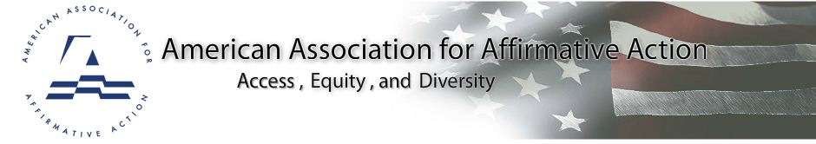
NEWS
American Association for Affirmative Action
Joins National Civil Rights Organizations in Commemorating
The Fiftieth Anniversary of the March on Washington
Affirmative Action association urges the Nation to Re-Affirm its Commitment to Equal Opportunity through Affirmative Action and Diversity

For Immediate Release: August 7, 2013
Contact: Shirley J. Wilcher
202-349-9855
240-893-9475

Washington, D.C., August 7, 2013 – The American Association for Affirmative Action (AAAA), an organization of equal opportunity, affirmative action and diversity professionals joins a stellium of national civil rights organizations in commemorating the 50th Anniversary of the March on Washington for Jobs and Freedom, on August 24, 2013. AAAA’s members and friends will join organizations and individuals from around the nation to remember the momentous March of 1963 and Dr. Martin Luther King Jr.’s famous “I Have a Dream” speech. AAAA President Gregory T. Chambers said, “On August 24th AAAA will stand on the steps of the Lincoln Memorial and remember where we were in 1963 when thousands of individuals stood for freedom, justice and equality.” He added, “In 2013, we will also consider how far we have come and the distance we must travel to realize Dr. King’s Dream.”

Among the issues of the 21st Century “National Action to Realize the Dream” March, including Voting Rights, Jobs, Immigration, LGBT rights, Health Care and Criminal Justice are the preservation of Equal Opportunity through Affirmative Action and Diversity programs. “The Fisher v. University of Texas at Austin case, which was heard by the US Supreme Court and remanded to lower courts for more deliberation, and the Schuette v. Cantrell case, which will be heard by the Court in October 2013, demonstrate the most recent, pernicious challenges to policies promoting access, equity and diversity,” said Marilynn Schuyler, AAAA Board Member and Regional Director (for Washington, DC). “The marchers in 1963 helped us to open the gates of opportunity in education, employment and contracting. We must now fight to keep those doors open.”

AAAA Executive Director Shirley J. Wilcher added: “The nation’s future depends upon all qualified individuals – including men, women and individuals with disabilities, veterans, people of color, religious minorities and members of the LGBT community -- having a chance to compete in education, employment and business. AAAA members will march to the King Memorial urging the nation to move forward towards equal opportunity for all. That is the dream of the 21st Century.”

Founded in 1974, the American Association for Affirmative Action (AAAA) is a national not-for-profit association of professionals working in the areas of affirmative action, equal opportunity, and diversity. AAAA assists its members to be more successful and productive in their careers. It also promotes understanding and advocacy of affirmative action to enhance access and equality in employment, economic and educational opportunities.

###
www.affirmativeaction.org
American Association for Affirmative Action
888 16th Street, NW
Suite 800
Washington, DC 20006
202.349.9855

